102-188 Project Management Project Management Team: Team 16
Real-World Projects—Progress Report
Progress Report for Week of: 12/04/2022 | Project Name: Hamil Home Construction

Project Manager Name:
TO: Instructor (submitted via Canvas), email to Project Teammates
SUBJECT: (Project Team Name) Progress Report for Week of: 12/04/2022

NOTE: Each team will rotate a team member to complete and submit this weekly progress report.
Tasks accomplished/decisions made for the period(s):
All decisions made and tasks accomplished with a remaining budget of $5,966.00.
Analysis of “Finishing the Project and Realizing the Benefits.”
Did your team close out your project successful or unsuccessful according to Time, Cost, Functionality and Stakeholder Satisfaction? Explain.

It looks like we had the lowest cost score among our peers, and I can understand why given how we missed hiring several key resources through the project. We failed to acquire a painter and landscaper in time for their respective tasks, so we had to scramble and assign resources that weren’t specialized in that area to complete them. As a result, their efficiency was very poor, and it ended up costing us a lot more than if we had hired the right resources. As the project went along, we discovered that instead of assigning 100% of someone to a task we could split up their time and realize a lot of efficiency we weren’t before. I believe this helped up cement the 2nd place spot. Realizing that project managers were always 70% efficient at a task, we also could have hired an additional project manager to complete tasks more efficiently.
Analysis of “Cost Overview Report” Open your final MS Project WBS Gantt chart for your project. Click on the Report tab, Dashboards, then Cost Overview. Review your report and list the top summary task that you were under cost and list the top summary task cost that you were over budget. Explain what your team could have done to correct the over budget summary task. Include a screen shot of your final Cost Overview and attach below. You may refer to the example screen shot below:

Site Preparation had an actual cost of $124,025.29 with a Baseline cost of $110,000.
Exterior Finishes had an actual cost of $10780.00 with a Baseline cost of 11,400.00.
On a few tasks during the project, we didn’t hire the correct resources for the given tasks, if we had managed to, we would’ve saved a lot on efficiency and therefore a lot of money spent on resources going overtime.

Cost Overview:
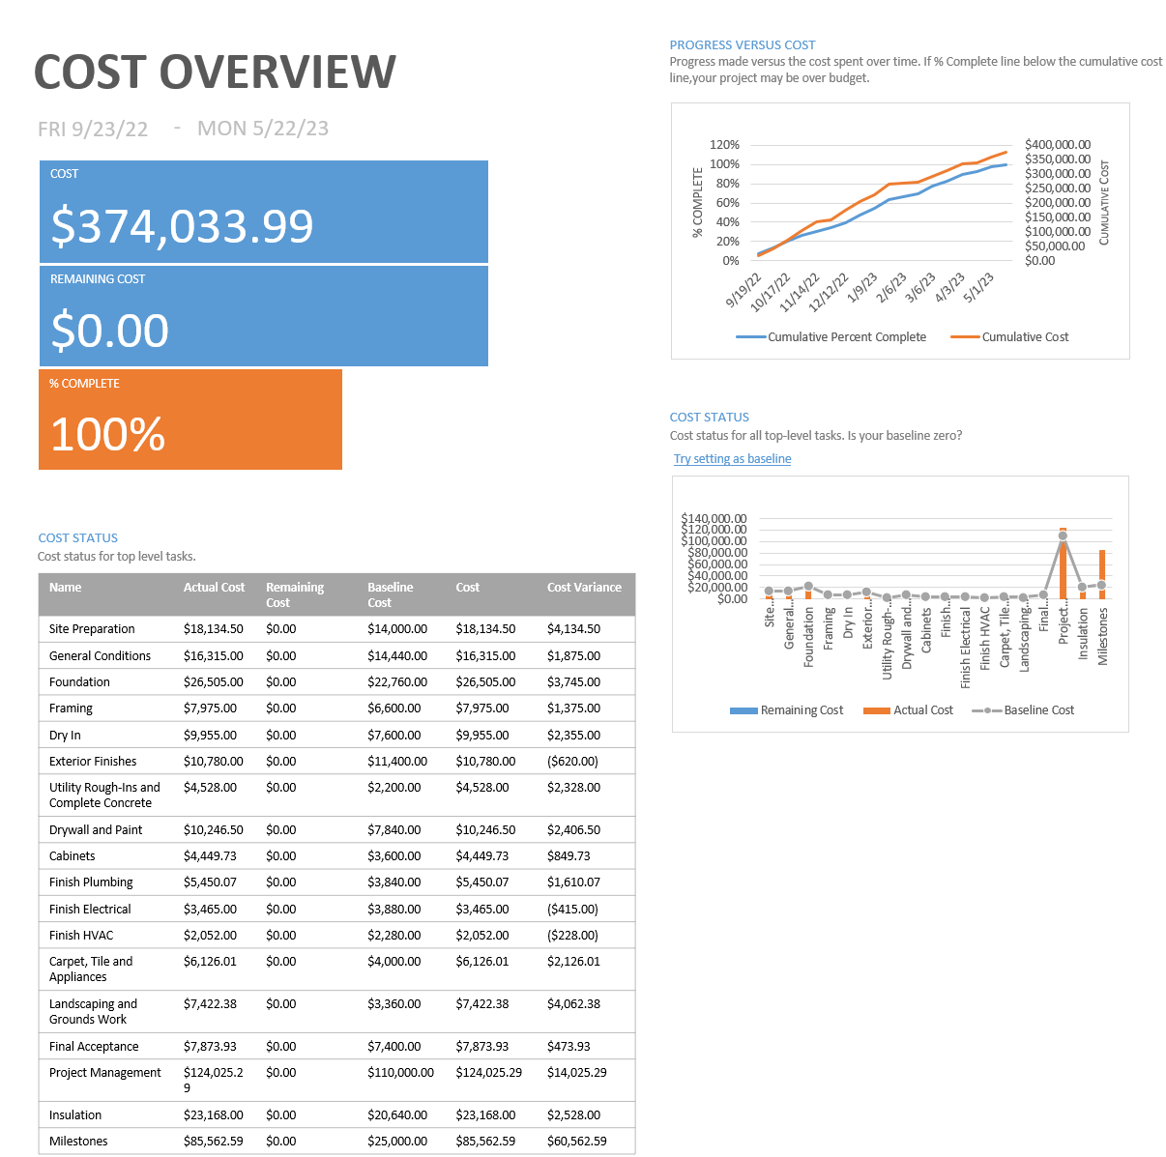
NEXT WEEK ACTION PLAN (Deadline dates & assigned Project Manager)
For the upcoming weeks we will have to decide on a direction to go regarding our final presentation. We will continue to work on our communication skills and efficacy.

